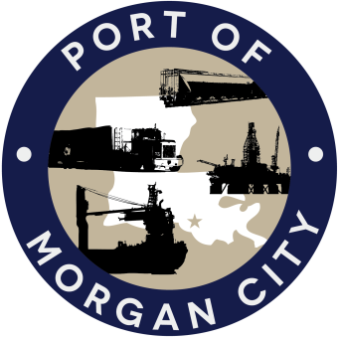

AGENDA

MORGAN CITY HARBOR AND TERMINAL DISTRICT
Regular Meeting of June 13, 2016 – 5:00 p.m. – 7327 Highway 182

- Call to Order

- Roll Call

- Invocation

- Pledge of Allegiance

- Minutes

Regular Meeting of May 9, 2016

- Finance Report
A. Presentation and discussion of financial reports for May 2016 – Deborah Garber
B. Invoices

Guest(s)
A. United States Coast Guard
B. Corps of Engineers, New Orleans District

Raymond “Mac” Wade - Executive Director’s Report

A. Consultant – Michael Knobloch, Knobloch Professional Services, LLC
B. Consultant – Clay Breaud, Providence/GSE
C. Consultant –Carl Blum, Architect
D. Cindy Cutrera, Manager of Economic Development

- Gerard Bourgeois - Legal Report

- New Business
    - Discussion and any action on Letter of “No Objection” from Perennial Environmental Services on behalf of Bayou Bridge Pipeline, LLC regarding the Bayou Bridge Pipeline Project
    - Discussion and any action on audit engagement letter from Darnall, Sikes, Gardes, and Frederick

- Old Business
A. Discussion and any action on leasing, improvements, maintenance and repairs to facility, including Coast Guard lease(s)
B. Discussion and any action regarding the U.S. Department of Homeland Security grant program, including request for proposals, bids, purchases, project management, generators, computer data system and NOAA ports system(s).
C. Discussion and any action on Government Operations and Emergency Center including bids, purchases, project agreements, change orders, inspection, payments, leasing and Facility Planning and Control
D. Discussion and any action on Atchafalaya River Channel dredging and sediment management, including survey services, consulting services and economic study(ies)
E. Discussion and any action on 2016 flood fight.

- Election of Officers – special

- Adjournment

In accordance with the Americans with Disabilities Act, if you need special assistance, please contact Tori Henry at 985-384-0850, describing the assistance that is necessary.

